

**Introduction to Python**

# 1.1 Introduction to Python

# 1.2 Beginning with Python programming

# 1.3 Features of Python

# 1.4 Dynamically Typed

# 1.5 Advantages

# 1.6 Disadvantages

# 1.7 Applications

# 

# 

# 

# 1.1 Introduction To PYTHON

Python is a high-level, general-purpose and a very popular programming language.

Python programming language (latest Python 3) is being used in web development, Machine Learning applications.

[Python](https://www.geeksforgeeks.org/python-programming-language/) is a widely used general-purpose, high level programming language. It was created by Guido van Rossum in 1991 and further developed by the Python Software Foundation. It was designed with an emphasis on code readability, and its syntax allows programmers to express their concepts in fewer lines of code.

Python is a programming language that lets you work quickly and integrate systems more efficiently.

There are two major Python versions: Python 2.X(2.7) and Python 3.X Both are quite different.

**1.2 Beginning with Python programming:**

**1) Finding an Interpreter:**

Before we start Python programming, we need to have an interpreter to interpret and run our programs. There are certain online interpreters like <https://ide.geeksforgeeks.org/> that can be used to run Python programs without installing an interpreter.

***Windows***: There are many interpreters available freely to run Python scripts like IDLE (Integrated Development Environment) that comes bundled with the Python software downloaded from <http://python.org/>. Local DEV TEST UAT PROD

***Linux*:** Python comes preinstalled with popular Linux distros such as Ubuntu and Fedora. To check which version of Python you’re running, type “python” in the terminal emulator. The interpreter should start and print the version number.

***macOS*:** Generally, Python 2.7 comes bundled with macOS. You’ll have to manually install Python 3 from <http://python.org/>.

**2) Writing our first program:**

Just type in the following code after you start the interpreter.

|  |
| --- |
| # Script Begins    print("welcome to python")    # Scripts Ends |

Output:

welcome to python

Let’s analyze the script line by line.

*Line 1: [*# Script Begins] In Python, comments begin with a #. This statement is ignored by the interpreter and serves as documentation for our code.

*Line 2: [print(“*welcome to python*”)]* To print something on the console, print() function is used. This function also adds a newline after our message is

printed(unlike in C). Note that in Python 2, “print” is not a function but a keyword and therefore can be used without parentheses. However, in Python 3, it is a function and must be invoked with parentheses.

*Line 3: [*# Script Ends] This is just another comment like in Line 1.

Python designed by Guido van Rossum at CWI has become a widely used general-purpose, high-level programming language.

**Reason for increasing popularity**

1. Code readability, shorter codes, ease of writing
2. Programmers can express logical concepts in fewer lines of code in comparison to languages such as C++ or Java.
3. Python supports multiple programming paradigms, like object-oriented, imperative and functional programming or procedural.
4. There exists inbuilt functions for almost all of the frequently used concepts.

**1.3.Features Of Python :**

i. **Interpreted**

* + There are no separate compilation and execution steps like C and C++.
  + Directly *run* the program from the source code.
  + Internally, Python converts the source code into an intermediate form called bytecodes which is then translated into native language of specific computer to run it.
  + No need to worry about linking and loading with libraries, etc.

**ii. Platform Independent**

* + Python programs can be developed and executed on multiple operating system platforms.
  + Python can be used on Linux, Windows, Macintosh, Solaris and many more.

**iii. Free and Open Source; Redistributable**

**iv. High-level Language**

* + In Python, no need to take care about low-level details such as managing the memory used by the program.

**v. Simple**

* + Closer to English language; Easy to Learn
  + More emphasis on the solution to the problem rather than the syntax

**vi. Embeddable**

* + Python can be used within C/C++ program to give scripting capabilities for the program’s users

**vii. Robust:**

* + Exceptional handling features
  + Memory management techniques in built

**viii. Rich Library Support**

* + The Python Standard Library is very vast.
  + It can help do various things involving regular expressions, documentation generation, unit testing, threading, databases, web browsers, CGI, email, XML, HTML, WAV files, cryptography, GUI and many more.
  + Besides the standard library, there are various other high-quality libraries such as the Python Imaging Library which is an amazingly simple image manipulation library.

Python vs JAVA

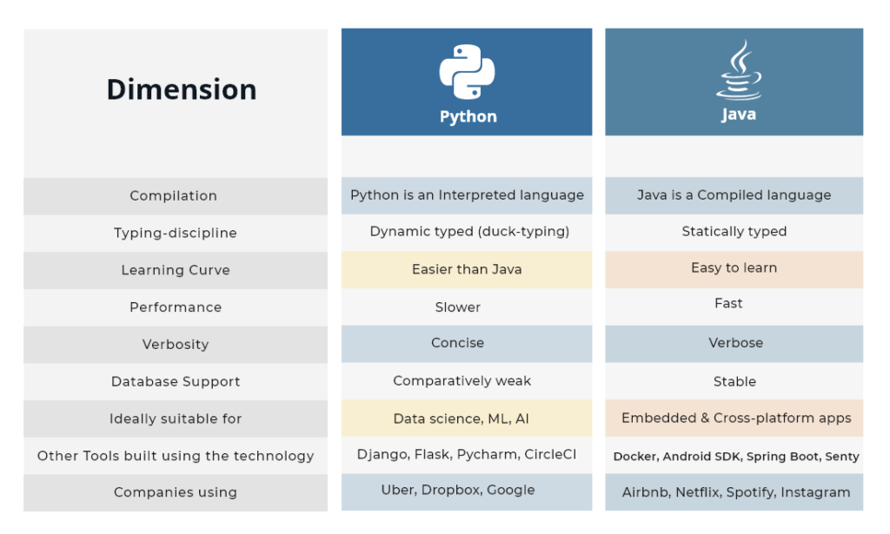

**1.4 Dynamically Typed:**

**int x = 10** # Int 🡺 type x 🡺 variable = 🡺 Operator 10 🡺 value

In Python , No need to declare the data type. whereas in java or c we have to declare the data type.

Statically typed languages perform type checking at compile-time, while dynamically-typed languages perform type checking at run-time. Statically-typed languages require you to declare the data types of your variables before you use them, while dynamically-typed languages do not**.**

**In Python:**

**x = 10**

**print(“Hello”)**

**Whereas in java, we need to declare data type**

Java Code

|  |
| --- |
| public class HelloWorld  {  public static void main (String[] args)  {  System.out.println("Hello, world!");  }  } |

Python Code

|  |
| --- |
| print("Hello, world!") |

Similarity with Java

* Require some form of runtime on your system (JVM/Python runtime)
* Can probably be compiled to executables without the runtime (this is situational, none of them are designed to work this way)

**GUI**

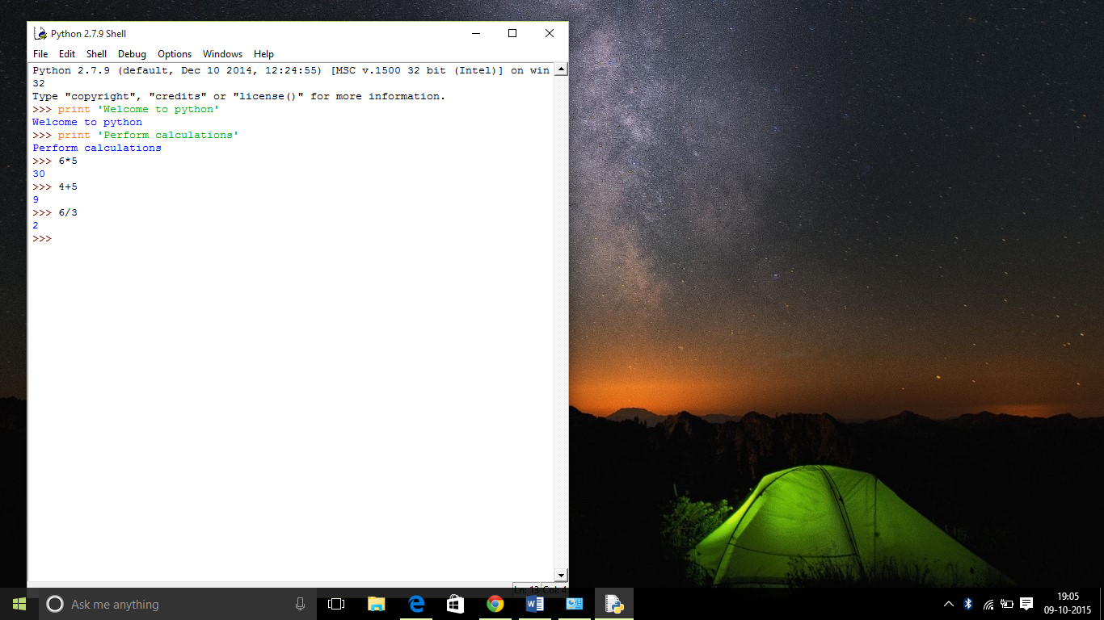

**Command Line interface**

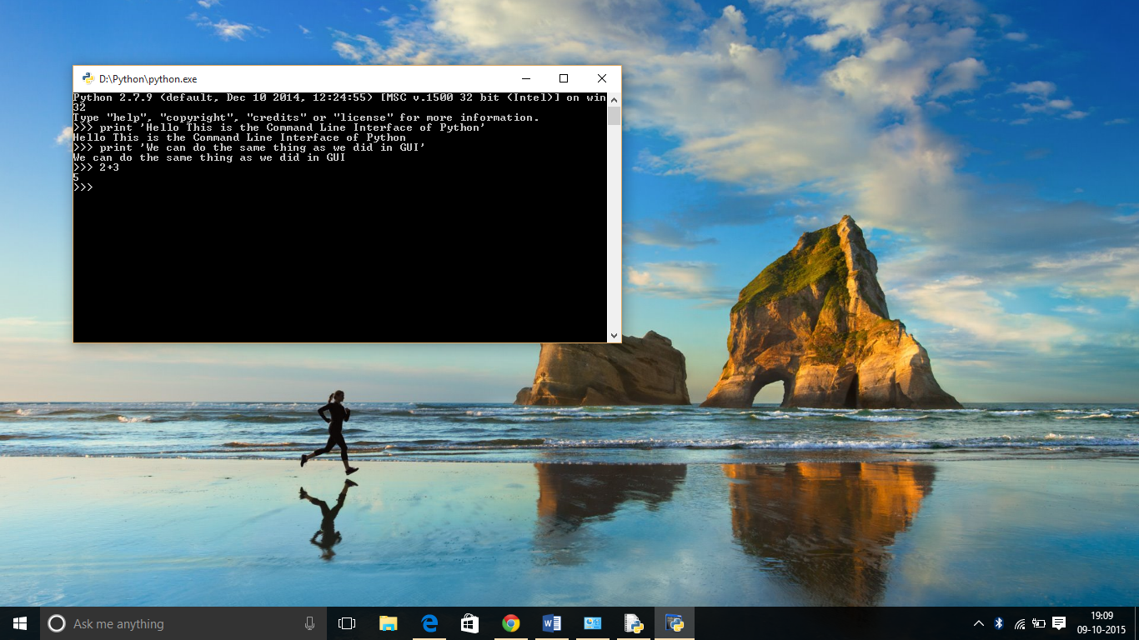

**1.5**.**Advantages :**

1. Presence of third-party modules
2. Extensive support libraries(NumPy for numerical calculations, Pandas for data analytics etc)
3. Open source and community development
4. Versatile, Easy to read, learn and write
5. User-friendly data structures
6. High-level language
7. Dynamically typed language (No need to mention data type based on the value assigned, it takes data type)
8. Object-oriented language
9. Portable and Interactive
10. Ideal for prototypes – provide more functionality with less coding
11. Highly Efficient(Python’s clean object-oriented design provides enhanced process control, and the language is equipped with excellent text processing and integration capabilities, as well as its own unit testing framework, which makes it more efficient.)
12. (IoT)Internet of Things Opportunities
13. Interpreted Language
14. Portable across Operating systems
15. Ease of use
16. Multi-paradigm Approach

**1.6.Disadvantages :**

1. Slow speed of execution compared to C,C++
2. Absence from mobile computing and browsers
3. For the C,C++ programmers switching to python can be irritating as the language requires proper indentation of code. Certain variable names commonly used like sum are functions in python. So C, C++ programmers have to look out for these.
4. Slow speed of execution compared to C,C++
5. Absence from mobile computing and browsers
6. For the C,C++ programmers switching to python can be irritating as the language requires proper indentation of code. Certain variable names commonly used like sum are functions in python. So C, C++ programmers have to look out for these.

### 

### 

### 

### 

### 

### 

### 1.7 Applications :

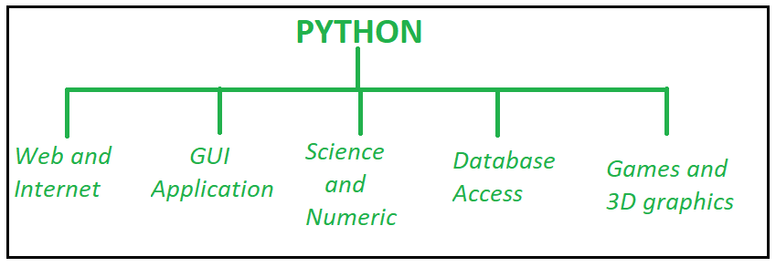

1. GUI based desktop applications
2. Graphic design, image processing applications, Games, and Scientific/ computational Applications
3. Web frameworks and applications
4. Enterprise and Business applications
5. Operating Systems
6. Education
7. Database Access
8. Language Development
9. Prototyping
10. Software Development  
    
11. Organizations using Python :
12. Google(Components of Google spider and Search Engine)
13. Yahoo(Maps)
14. YouTube
15. Mozilla
16. Dropbox
17. Microsoft
18. Cisco
19. Spotify
20. Quora